**Testing Result**

***US 21145*** Sending the transaction related information from the TPMS Sub System to IBTS

* Step 1: IBTS service send transaction data in **Classification_home_agency**

Json Format

{

"accountAgencyId": 1,

"actualAxles": 2,

"actualClass": 0,

"actualExtraAxles": 2,

"aetFlag": "Y",

"collectedAmount": 0,

"collectorAxles": 0,

"collectorClass": 0,

"collectorId": "78999",

"corrReasonId": 0,

"depositId": 0,

"deviceAxles": 2,

"deviceNo": "00411571479",

"deviceProgramStatus": 0,

"deviceReadCount": 37,

"deviceWriteCount": 0,

"discountedAmount": 0,

"entryDataSource": "T",

"entryDeviceReadCount": 37,

"entryDeviceWriteCount": 0,

"entryLaneId": 6963,

"entryPlazaId": 603,

"etcAccountId": 54,

"etcTxStatus": 71,

"eventTimestamp": "2021-06-01T09:45:57.033",

"eventType": 4,

"externFileId": 97,

"forwardAxles": 0,

"fullFareAmount": 152,

"imageTaken": "F",

"isDiscountable": "N",

"isMedianFare": "N",

"isPeak": "N",

"isReversed": "N",

"laneHealth": 0,

"laneId": 18003,

"laneMode": 9,

"laneTxId": 1466,

"laneTxStatus": 0,

"mileage": 0,

"planTypeId": 0,

"plateNumber": "NDL48Y",

"plateState": "NJ",

"plazaAgencyId": 1,

"plazaId": 72,

"postDeviceStatus": 0,

"preTxnBalance": 0,

"prevViolTxStatus": 0,

"priceScheduleId": 0,

"readAviAxles": 2,

"receiptIssued": 0,

"reconStatusInd": 0,

"reconSubCodeInd": 0,

"revenueDate": "2021-04-13",

"reverseAxles": 0,

"tollRevenueType": 9,

"tollSystemType": "E",

"txDate": "2021-04-15",

"txExternRefNo": "0000023509000076",

"txModSeq": 0,

"txSeqNumber": 28753,

"txSubtypeInd": "F",

"txTimestamp": "2021-04-23 14:00:12.065",

"txTypeInd": "V",

"unrealizedAmount": 0,

"updateTs": "2021-06-01T09:45:57.033",

"violTxStatus": 5,

"violType": 3,

"sourceSystem": 1

}

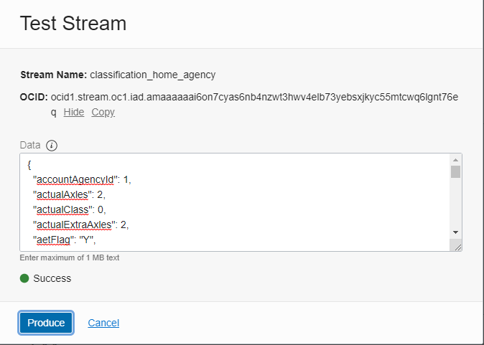

* Step 2:

Toll posting service read transaction record from **Classification_home_agency** queue.

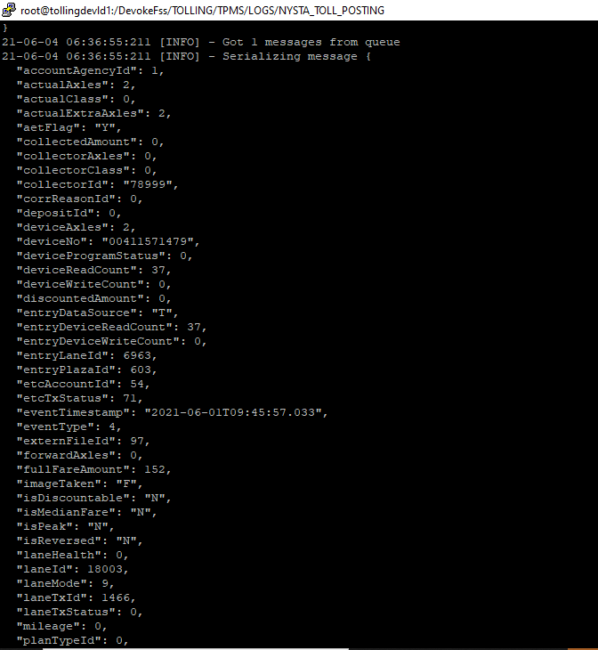

And send to toll_posting rest api (FPMS).

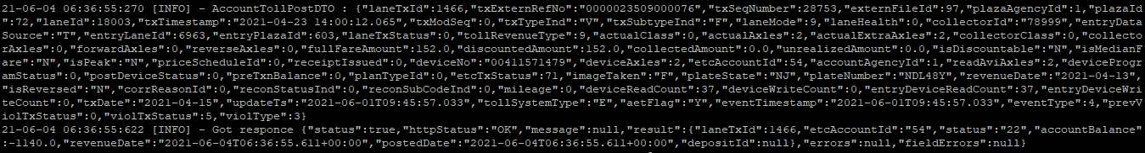

* Step 3

Once Toll posting api (FPMS) send back response toll posting service update that result in T_TRAN_DETAIL table and push that result in **IBTS_Posting_Result_Queue**



